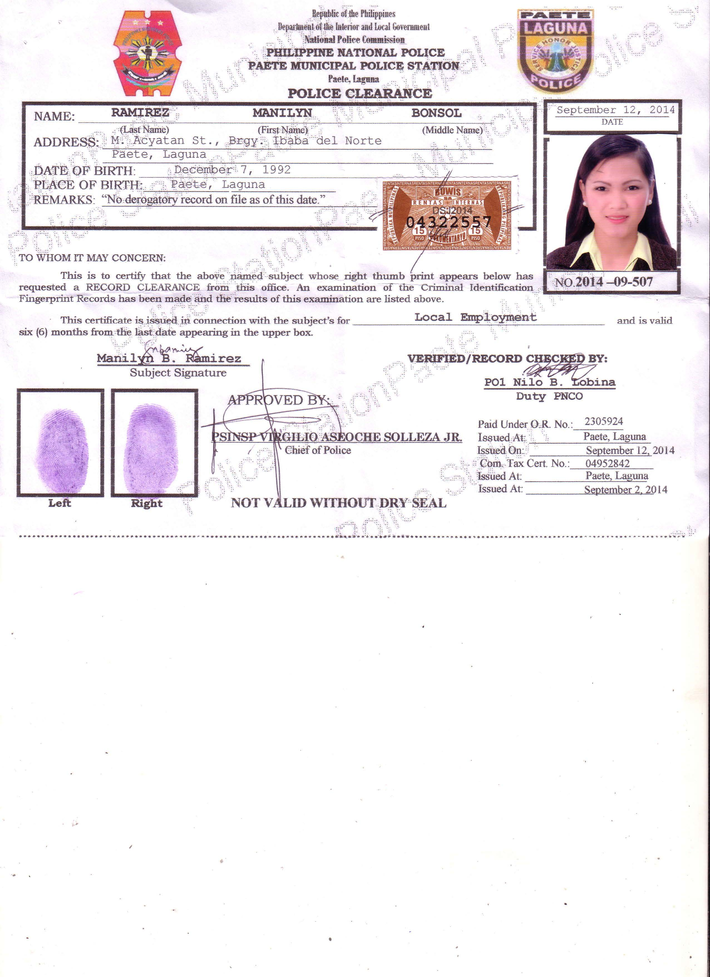**Manilyn B. Ramirez**

156 M. Acyatan St. Brgy 9 Ibaba del Norte

Paete, Laguna

Mobile No. 09075439715

Birth date: December 7, 1992

Email Add: [manilynramirez027@yahoo.com](mailto:manilynramirez027@yahoo.com)

**CAREER OBJECTIVE**

A position as a Sales Staff where my administrative experience and communication abilities will be useful in fostering the growth of your organization.

**HIGHLIGHTS OF QUALIFICATIONS**

* Experience in administrative positions.
* Proficient in Microsoft Offices (Word, Excel, Power Point, and Outlook).
* Strong communication abilities.
* High energy, dynamic and a quick learner.
* Well-trained in handling documents.
* Can perform duties/tasks assigned by her superiors in support of the goals and objectives of the business.

**WORK EXPERIENCE**

On-the-Job Training Rural Bank of Magdalena

Paete, Laguna (April-July 2012)

* Record Keeping
* Encoding
* Scanning and printing
* Answer Telephone Calls
* Journalizing Transactions

Production Operator Transitions Optical Phils, Inc

Binan, Laguna (July-December 2013)

* Operated machines
* Prepared documents needed in production line

Office Encoder Fujitsu Die-Tech Corporation of the Philippines

Binan, Laguna (February-May 2014)

* Encodes the Daily Work Record in database
* Update and maintain all important records
* Prepared documents in MS Word and Excel
* Performed other office duties as necessary

Sales Staff Fujitsu Die-Tech Corporation of the Philippines

Binan, Laguna (September 2014 – present)

* In-charge in preparing sales documents and records.
* Perform Customer Service
* Coordinates with customers regarding their concerns and suggestion.
* Support other task division/section.
* Document Controller.

**EDUCATIONAL ATTAINMENT**

Tertiary ACTS Computer College

Sta. Cruz, Laguna

Course : Bachelor of Science in Business

Administration Major in Management with Computer Application

Position Paper : An Assessment on the Marketing Strategies

Implemented by the Selected Handicraft Stores in Paete, Laguna

Graduated : S.Y. 2012-2013

Secondary Poten & Eliseo Quesada Memorial National High School

Paete, Laguna

Graduated : S.Y. 2008-2009

**SEMINARS ATTENDED**

September 04, 2010 - Personality Development

October 22, 2011 - Solid Waste Management Through

Vermicomposting Technology

February 09, 2012 - ACTS 1st BEST (Business, Entrepreneur,

Synergies Symposium Thrust of a Sustainable Economy)

March 02, 2013 - ACTS 2nd BEST (Business, Entrepreneur,

Synergies Symposium Thrust of a Sustainable Economy)

March 21, 2013 - Job Hunting Symposium

November 10, 2015 - Quality Customer Service

December 16, 2015 - Developing and Controlling QMS Documents and Records / DC Toolbox Awareness

**CHARACTER REFERENCES**

**Mr. Alvin Comia**  **Mrs. Lolita A. Acupanda**

Asst. Sales & Design Manager Branch Manager

Fujitsu Die-Tech Corporation of the Philippines Rural Bank of Magdalena-Paete

Binan, Laguna Paete, Laguna

Contact No. 09175924500 Tel. No. 557-2207